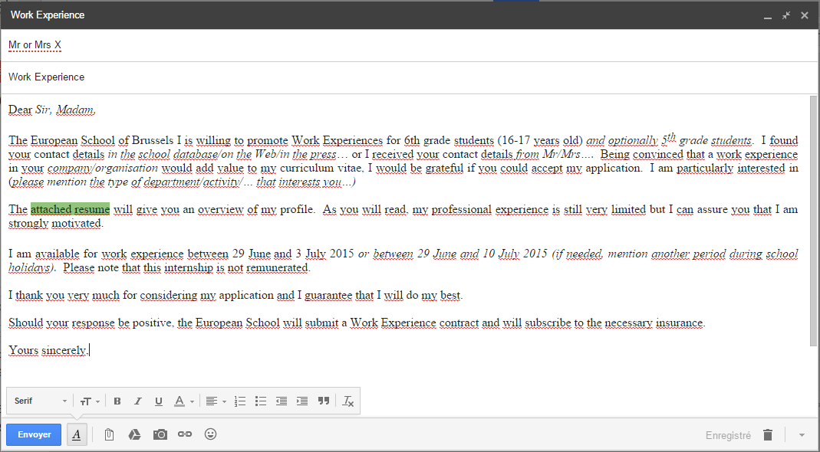

More readable text

Dear *Sir, Madam,*

The European School of Brussels I is willing to promote Work Experiences for 6th grade students (16-17 years old) *and optionally 5th grade students*. I found your contact details *in the school database/on the Web/in the press*… or I received your contact details *from Mr/Mrs….* Being convinced that a work experience in your *company/organisation* would add value to my curriculum vitae, I would be grateful if you could accept my application. I am particularly interested in (*please mention the type of department/activity/… that interests you…)*

The attached resume will give you an overview of my profile. As you will read, my professional experience is still very limited but I can assure you that I am strongly motivated.

I am available for work experience between 27 Juneand 1 July 2016 *or between 27 June and 8 July 2016 (if needed, mention another period during school holidays).* Please note that this internship is not remunerated.

I thank you very much for considering my application and I guarantee that I will do my best.

Should your response be positive, the European School will submit a Work Experience contract and will subscribe to the necessary insurance.

Yours sincerely,